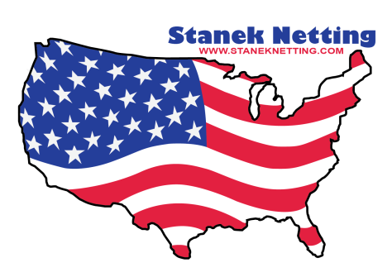
Stanek Netting Co., Inc.
_High Quality Netting Products ____________________

PRODUCT SPECIFICATION SHEET

PRODUCT NAME
Style #5000

DESCRIPTION

WEIGHT: 6 oz/Sq. YD. +/- .2/oz.
HOLE SIZE: 3/16” (+/-1/16”)
WIDTH: 50”, 62”
ROLLS SIZES: Approx 150 yards or as per customer spec.
PACKAGING: Packed on 3” Cardboard Tubes.
MINIMUM QTY
PER COLOR: 300 yards on stock items. 2000 yards on non-stock items.
COLOR: Various
YARN CONTENT: 100% Polyester with a combination of 150/840 Denier Yarn.
FINISHING: This material goes through a heat process @ 385 degrees with a Melamine resin to give it a Medium Firm Finish.
FABRIC TYPE: Raschel Knitted Fabric.
COUNTRY OF ORIGIN: USA

