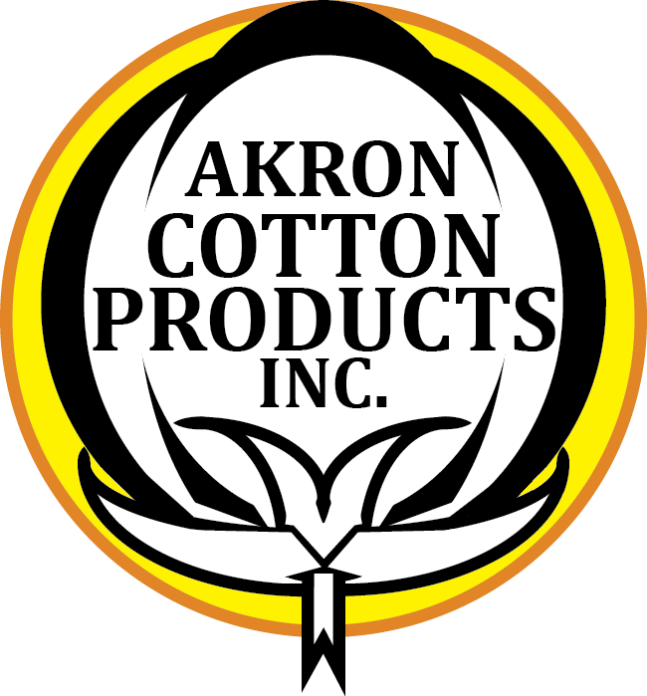
AKRON COTTON PRODUCTS, INC.
437 W. CEDAR ST.
AKRON, OH 44307
330-434-7171|AKRONCOTTON@AKRONCOTTON.COM
ACH Payment Authorization Form
Schedule your payment to be automatically deposited to your checking or savings account.
Just complete and sign this form to get started!

Please complete the information below:

I ____________________________ authorize AKRON COTTON PRODUCTS, INC. to credit my bank account
(full name)

Billing Address ____________________________ Phone# ________________________
City, State, Zip ____________________________ Email ________________________

Account Type: Checking Savings
Name on Acct _______________________________
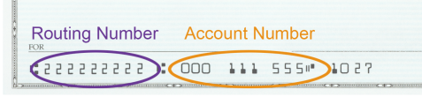
Bank Name _______________________________
Account Number _______________________________
Bank Routing # _______________________________
Bank City/State _______________________________

SIGNATURE DATE

