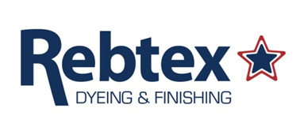

June 2nd, 2026

Re: 2026 Pricing

Dear Valued Rebtex Customers,
~~
We hope this finds you well! We value our partnership and always strive to provide you with the highest quality products and services. Due to recent and unforeseen increases in our supply costs across the board, we must implement a temporary supply surcharge on all orders processed on or after the dates listed below. Please note that these surcharges are calculated on current pricing and are not cumulative.

Effective date Surcharge
June 15, 2026 2.4% surcharge on current 6/2/26 pricing
July 1, 2026 3.4% surcharge on current 6/2/26 pricing
July 15, 2026 4.4% surcharge on current 6/2/26 pricing
August 1, 2026 5.4% surcharge on current 6/2/26 pricing

We do not make this decision lightly, but this adjustment ensures we can continue delivering the reliability and standards you expect from us. We will monitor market conditions closely and revisit this in 60 days to fine tune the surcharge as needed.

We appreciate your business and value your trust in Rebtex and Stanek Netting.

Please note that it goes without saying that we are taking this one day at a time, we can’t predict what the next few months will bring but we will do our best to keep operating as usual. Please stay safe, stay healthy, and have a great 2026!
~~

Regards,

_________________________

James Stanek
Vice President
Stanek Netting Company Inc.
Rebtex Dyeing and Finishing

