Entire Building For Sale - 35 W 38th St.
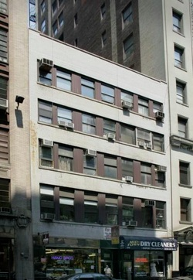

Sale Price: $12,500,000
NNN Lease Price: $48k/Month
Cross Streets: Between 5th & 6th Avenues.
Square Footage: 13,400
Lot Size: 37.5x100
Block & Lot: 840-21
Zoning: M1-6 (Hotel/Commercial/Manufacturing)
Stories: 5 Floors (above ground)
Layout: Two stories per floor with the stairs & elevator in the center.
Elevator: Opens on both sides into the lofts
Downtown Commercial Real Estate, Inc. 800-750-6013
Taxes: $60k
Expenses: $20k
Current Income: $300k
Potential Income from Empty Units: $180k
Total Potential Income: $480k


