December 13,2018
Claude Simon
Charles Henry Properties, LLC.
To Whom It May Concern:
The issues raised by the inspector consist mostly of a failure of knowledge and effort on his part and I seem to be taking my personal time to do his job without compensation. This is not what I get paid for, it is what the inspector gets paid for.
He called and made an appointment and assured us, he would be “quick, in and out”. Well, our representative was there and he was “quick, in and out” just like he said. He left by saying, “the only issue is the handrail”.
Now comes this surprise silly list which “does not read favorably”.
Certificate of Occupancy
I purchased this building in 2013. Now tell me how the building went through a 2013 closing with title insurance report and a 2016 loan closing without a Certificate of Occupancy that matched the usage???? Your inspector must be a genius to have exposed the error of 50 other people who poured over the building documents.
Here it is:
Dryer Venting-
Dryer vents were inspected by the city in 2013 pursuant to a tenant complaint and no violation was found. “No violation warranted for complaint at time of inspection” “No illegal ventilation observed”.
Dryer vents were subsequently upgraded to galvanized steel.
Here’s the document:

Electrical
Building electrical was completely renewed including service entrance and service panels prior to purchase in 2013. We observe no “sub-standard” wiring. His comment reads like the basement building is full of extension cords. Show me a single NYC violation on electric work or ANY open violation for that matter.
Here is the comment from the home inspector at the time of purchase:
Here is the comment from Harleysville inspector at time of inspection:
Gas
What a joke!!!
In winter, 2018, a Con Ed gas leak in the street led to the shut off of all gas to the building. Pursuant to Con Ed and NYC rules, the building gas was pressure tested. All leaks were repaired by Bargain Plumbing and Heating, LLC and all appliances were inspected by Con Edison at that time. The gas was restored. There are no gas appliance or piping issues in the building. No further inspection is required or warranted. I spent $22,000 getting the gas lines sealed so they would pass Con Ed inspection where NO LEAK was even reported or detected before Con Ed put a reciprocating saw to our line.
Here’s the plumbing bill:

Here’s the tag on the line (this is in the basement where the inspector should have seen it);
Basement Framing
Basement framing consists of non-load bearing partitions which do not require inspection and are under no circumstances substandard or represent a safety hazard. Other building structural framing was inspected and approved at the time of purchase in 2013.
Handrail
The handrail has been secured. We used a screwdriver. They’re going up and down the stairs with laundry. Do you think they’re using the handrail? Are you covering us if they fall down the stairs?
Here’s a picture:

Laundry License
Following is the Retail Laundry license for the store which is available to the general public online (does the inspector have a computer?):
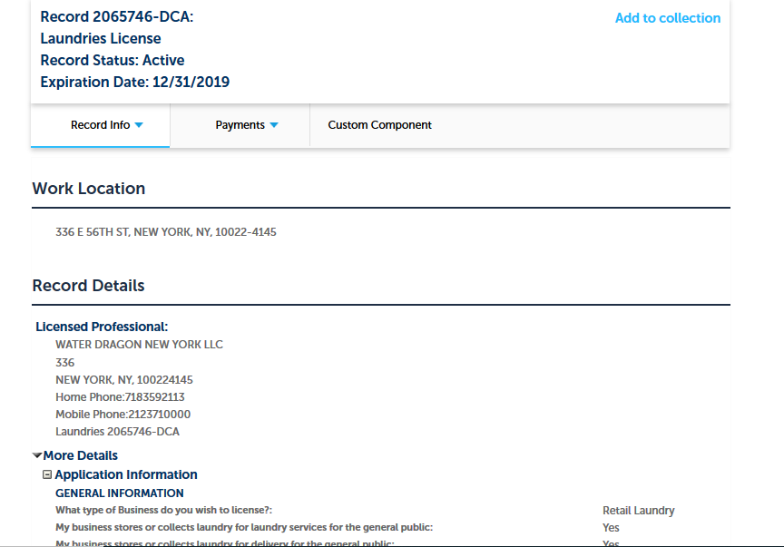
Finally, please tell me how we have successfully fooled two other insurance companies inspectors prior to Andover. Also tell me how the retail tenant, Waterdragon LLC, also obtained insurance per the following without a successful, uneventful inspection??
Why are you paying some jackass to do inspections?

Sincerely,
Claude Simon

